2025 Micro Soccer Schedule

3 & 4 Year Old Division

**April 2 April 9 Teams**

5:30 5:50 6:10 5:30 5:50 6:10 1 - Basilio

**Field 1** - 1 v **6** 5 v **6** 3 v **6** **Field 1** - 6 v **2** 10 v **2** 8 v **2** 2 - Umana

**Field 2** - 2 v **7** 1 v **7** 5 v **7** **Field 2** - 3 v **7** 6 v **7** 10 v **7** 3 - Barley

**Field 3** - 4 v **8** 2 v **8** 1 v **8**  **Field 3** - 5 v **4** 3 v **4** 6 v **4** 4 - C. Mach

**Field 4** - 3 v **9** 4 v **9** 2 v **9** **Field 4** - 8 v **1** 5 v **1** 3 v **1** 5 - Keller

**Field 5 -** 5 v **10** 3 v **10** 4 v **10 Field 5 -** 10 v **9** 8 v **9** 5 v **9** 6 - Brooks

**April 16 April 23** 7 - Lopez Franco

5:30 5:50 6:10 5:30 5:50 6:10 8 - Bolanos

**Field 1** - 9 v **4** 6 v **4** 8 v **4** **Field 1** - 10 v **8** 4 v **8** 9 v **8** 9 - Baeza

**Field 2** - 7 v **3** 9 v **3** 6 v **3** **Field 2** - 2 v **3** 10 v **3** 4 v **3**  10 - Bello

**Field 3** - 1 v **5** 7 v **5** 9 v **5** **Field 3** - 7 v **1** 2 v **1**  10 v **1**

**Field 4 -** 8 v **2** 1 v **2** 7 v **2 Field 4** -9 v **6** 7 v **6** 2 v **6**

**Field 5** - 6 v **10** 8 v **10** 1 v **10 Field 5 -** 4 v **5** 9 v **5** 7 v **5**

- We will play (3) three 15 minute games per night.

- The second team listed (**in** **Bold)** will stay on the same field for the evening. The first team listed will rotate fields throughout the evening.

---------------------------------------------------------------------------------------------------------------------------------------------------

5 & 6 Year Old Division

**April 2 April 9 Teams**

6:45 7:05 7:25 6:45 7:05 7:25 1 - Lopez

**Field 1** - 1 v **6** 5 v **6** 3 v **6** **Field 1** - 6 v **2** 10 v **2** 8 v **2** 2 - Bell

**Field 2** - 2 v **7** 1 v **7** 5 v **7** **Field 2** - 3 v **7** 6 v **7** 10 v **7** 3 - B. Mach

**Field 3** - 4 v **8** 2 v **8** 1 v **8**  **Field 3** - 5 v **4** 3 v **4** 6 v **4** 4 - Osborn

**Field 4** - 3 v **9** 4 v **9** 2 v **9** **Field 4** - 8 v **1** 5 v **1** 3 v **1** 5 - Schefdore

**Field 5 -** 5 v **10** 3 v **10** 4 v **10 Field 5 -** 10 v **9** 8 v **9** 5 v **9** 6 - Crystal Avalos

**April 16 April 23** 7 - Jesus Avalos

6:45 7:05 7:25 6:45 7:05 7:25 8 - Isis Avalos

**Field 1** - 9 v **4** 6 v **4** 8 v **4** **Field 1** - 10 v **8** 4 v **8** 9 v **8** 9 - Rajaniemi

**Field 2** - 7 v **3** 9 v **3** 6 v **3** **Field 2** - 2 v **3** 10 v **3** 4 v **3**  10 - Cathey

**Field 3** - 1 v **5** 7 v **5** 9 v **5** **Field 3** - 7 v **1** 2 v **1**  10 v **1**

**Field 4 -** 8 v **2** 1 v **2** 7 v **2 Field 4** -9 v **6** 7 v **6** 2 v **6**

**Field 5** - 6 v **10** 8 v **10** 1 v **10 Field 5 -** 4 v **5** 9 v **5** 7 v **5**

- We will play (3) three 15 minute games per night.

- The second team listed (**in** **Bold)** will stay on the same field for the evening. The first team listed will rotate fields throughout the evening.

-------------------------------------------------------------------------------------------------------------------------------

Soccer Fields - Fields are located at Rotary Park, 9th & Kingwood.

If games are canceled due to weather, the make-up date will be April 30th.

 Team and individual pictures will be taken on April 9th by R2K Photography.

Map of fields on back →

ROTARY PARK – MICRO SOCCER FIELDS

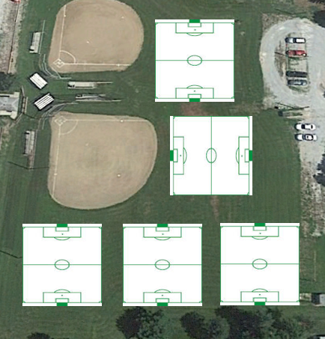

3

4

5

1

2